Internship Project Report

Title: Unlocking YouTube Channel Performance Secrets

Internship Domain: Data Analyst

Tools Used: Python, Pandas, Seaborn, Matplotlib, Jupyter Notebook

Submitted by – Ranjeet Singh

Contents

- Introduction
- Data Exploration
2.1 Dataset Overview
2.2 Distribution Analysis
2.3 Data Quality & Anomalies
- Correlation Analysis
- Predictive Modeling
4.1 Model Selection
4.2 Model Performance
4.3 Feature Importance
- Feature Engineering
- Time-Series Analysis
- Key Insights
- Recommendations
- Conclusion

1. Introduction
This project analyzes a dataset of 364 YouTube videos with 70 performance metrics, including views, revenue, watch time, engagement, and publishing details. The goal was to uncover insights into what drives monetization and engagement, and to build predictive models for estimating revenue.
2. Data Exploration
- Distributions:
  - Video durations are right-skewed, with most videos under 15 minutes.
  - Revenue and views are heavily skewed: most videos earn little, while a few viral ones dominate.
- Anomalies:
  - Outliers in average view percentage (>100%).
- Key Stats:
  - Average views per video: ~128k
  - Average revenue per video: ~$8.85
  - Average CTR: ~7.9%
3. Correlation Analysis
- Strong correlations:
  - Views ↔ Watch Time (hours)
  - Views ↔ Impressions
  - Revenue ↔ Views
- Moderate correlations:
  - Engagement metrics (Likes, Shares, Comments) with revenue.
Insight: Revenue is not purely a function of views; CTR, CPM, and engagement amplify monetization efficiency.
4. Predictive Modeling
- Model Used: Random Forest Regressor
- Performance:
  - RMSE ≈ 0.45
  - MAE ≈ 0.25
- Feature Importance:
  - Views, Watch Time, Impressions, CTR, Subscribers gained, Likes, and Average View Duration were the top predictors.
Insight: Beyond raw views, audience retention and engagement are critical for revenue.
5. Feature Engineering
- Log-transformed Views: Normalized skewed distributions.
- Flags:
  - Long video indicator (above median duration).
  - Weekend publishing indicator.
- Time Features: Extracted publish hour and weekday.
Impact: These features improved interpretability and highlighted posting-time effects.
6. Time-Series Analysis
- Daily AdSense revenue showed episodic spikes, tied to viral uploads.
- No steady growth trend; revenue is event-driven.
- Seasonality (month/day-of-week) could be further explored.
7. Key Insights
- Revenue is driven by views but amplified by CTR, watch time, and engagement.
- Most videos earn little; a few viral ones dominate revenue.
- Audience retention (avg view duration) and thumbnail CTR are critical for monetization.
8. Recommendations
- Improve Thumbnail CTR: A small increase in CTR can significantly boost impressions-to-views conversion.
- Focus on Retention: Longer videos with high average view duration generate more watch time and revenue.
- Optimize Publishing Schedule: Analyze weekday/weekend and hour-of-day effects to maximize reach.
- Engagement Strategy: Encourage likes, comments, and shares to boost algorithmic promotion.

9. Conclusion
This internship project provided hands-on experience in data exploration, visualization, feature engineering, and machine learning modeling. The analysis demonstrated how views, engagement, and retention drive YouTube monetization.

Code with Output

import pandas as pd
# Load CSV and parse publish time
df = pd.read_csv('youtube_channel_real.csv')
# Inspect structure and summary
print(df.head())
print(df.info())
print(df.describe())
ID Video Duration Video Publish Time Days Since Publish Day Month \
0 0 201.0 2016-06-02 00:00:00 0 2 6
1 1 391.0 2016-06-10 00:00:00 8 10 6
2 2 133.0 2016-06-14 00:00:00 4 14 6
3 3 14.0 2016-06-29 00:00:00 15 29 6
4 4 45.0 2016-07-01 00:00:00 2 1 7
Year Day of Week Revenue per 1000 Views (USD) \
0 2016 Thursday 0.024
1 2016 Friday 0.056
2 2016 Tuesday 0.014
3 2016 Wednesday 0.004
4 2016 Friday 0.000
Monetized Playbacks (Estimate) ... Watched (Not Skipped) (%) \
0 723.0 ... 0.0
1 727.0 ... 0.0
2 76.0 ... 0.0
3 18.0 ... 0.0
4 0.0 ... 0.0
Feed Impressions Average View Percentage (%) Average View Duration \
0 0.0 40.38 81.0
1 0.0 39.85 156.0
2 0.0 30.88 41.0
3 0.0 103.05 14.0
4 0.0 55.70 25.0
Views Watch Time (hours) Subscribers Estimated Revenue (USD) \
0 23531.0 533.1636 51.0 0.561
1 11478.0 500.5628 33.0 0.648
2 6153.0 70.7287 8.0 0.089
3 4398.0 17.6251 2.0 0.017
4 14659.0 104.3341 28.0 0.000
Impressions Video Thumbnail CTR (%)
0 41118.0 27.66
1 41627.0 5.85
2 38713.0 7.07
3 35245.0 5.60
4 46218.0 8.62
[5 rows x 70 columns]
<class 'pandas.core.frame.DataFrame'>
RangeIndex: 364 entries, 0 to 363
Data columns (total 70 columns):
# Column Non-Null Count Dtype
--- ------ -------------- -----
0 ID 364 non-null int64
1 Video Duration 364 non-null float64
2 Video Publish Time 364 non-null object
3 Days Since Publish 364 non-null int64
4 Day 364 non-null int64
5 Month 364 non-null int64
6 Year 364 non-null int64
7 Day of Week 364 non-null object
8 Revenue per 1000 Views (USD) 364 non-null float64
9 Monetized Playbacks (Estimate) 364 non-null float64
10 Playback-Based CPM (USD) 364 non-null float64
11 CPM (USD) 364 non-null float64
12 Ad Impressions 364 non-null float64
13 Estimated AdSense Revenue (USD) 364 non-null float64
14 DoubleClick Revenue (USD) 364 non-null float64
15 YouTube Ads Revenue (USD) 364 non-null float64
16 Watch Page Ads Revenue (USD) 364 non-null float64
17 YouTube Premium (USD) 364 non-null float64
18 Transaction Revenue (USD) 364 non-null float64
19 Transactions 364 non-null float64
20 Revenue from Transactions (USD) 364 non-null float64
21 Reactions 364 non-null float64
22 Chat Messages Count 364 non-null float64
23 Reminders Set 364 non-null float64
24 Stream Hours 364 non-null float64
25 Remix Views 364 non-null float64
26 Remix Count 364 non-null float64
27 Subscribers from Posts 364 non-null float64
28 New Comments 364 non-null float64
29 Shares 364 non-null float64
30 Like Rate (%) 364 non-null float64
31 Dislikes 364 non-null float64
32 Likes 364 non-null float64
33 Unsubscribes 364 non-null float64
34 New Subscribers 364 non-null float64
35 Returned Items (USD) 364 non-null float64
36 Unconfirmed Commissions (USD) 364 non-null float64
37 Approved Commissions (USD) 364 non-null float64
38 Orders 364 non-null float64
39 Total Sales Volume (USD) 364 non-null float64
40 End Screen Click-Through Rate (%) 364 non-null float64
41 End Screen Impressions 364 non-null float64
42 End Screen Clicks 364 non-null float64
43 Teaser Click-Through Rate (%) 364 non-null float64
44 Teaser Impressions 364 non-null float64
45 Teaser Clicks 364 non-null float64
46 Card Click-Through Rate (%) 364 non-null float64
47 Card Impressions 364 non-null float64
48 Card Clicks 364 non-null float64
49 Views per Playlist Start 364 non-null float64
50 Playlist Views 364 non-null float64
51 Playlist Watch Time (hours) 364 non-null float64
52 Clip Watch Time (hours) 364 non-null float64
53 Clip Views 364 non-null float64
54 YouTube Premium Watch Time (hours) 364 non-null float64
55 YouTube Premium Views 364 non-null float64
56 Returning Viewers 364 non-null float64
57 New Viewers 364 non-null float64
58 Average Views per User 364 non-null float64
59 Unique Viewers 364 non-null float64
60 Watched (Not Skipped) (%) 364 non-null float64
61 Feed Impressions 364 non-null float64
62 Average View Percentage (%) 364 non-null float64
63 Average View Duration 364 non-null float64
64 Views 364 non-null float64
65 Watch Time (hours) 364 non-null float64
66 Subscribers 364 non-null float64
67 Estimated Revenue (USD) 364 non-null float64
68 Impressions 364 non-null float64
69 Video Thumbnail CTR (%) 364 non-null float64
dtypes: float64(63), int64(5), object(2)
memory usage: 199.2+ KB
None
ID Video Duration Days Since Publish Day Month \
count 364.000000 364.000000 364.000000 364.000000 364.000000
mean 181.500000 664.239011 8.406593 15.807692 6.642857
std 105.221988 330.646183 15.371239 8.924004 3.421521
min 0.000000 9.000000 0.000000 1.000000 1.000000
25% 90.750000 496.000000 3.000000 8.000000 4.000000
50% 181.500000 613.000000 5.000000 16.000000 7.000000
75% 272.250000 786.500000 9.000000 23.000000 10.000000
max 363.000000 2311.000000 260.000000 31.000000 12.000000
Year Revenue per 1000 Views (USD) \
count 364.000000 364.000000
mean 2018.736264 0.112283
std 2.530629 0.179668
min 2016.000000 0.000000
25% 2017.000000 0.015000
50% 2018.000000 0.050000
75% 2021.000000 0.143500
max 2024.000000 1.600000
Monetized Playbacks (Estimate) Playback-Based CPM (USD) CPM (USD) \
count 364.000000 364.000000 364.000000
mean 8934.711538 1.553734 1.059005
std 12967.843236 1.078549 0.728380
min 0.000000 0.000000 0.000000
25% 349.500000 0.817750 0.522000
50% 3564.000000 1.540500 1.155500
75% 13579.250000 2.025250 1.458750
max 100566.000000 7.385000 6.295000
... Watched (Not Skipped) (%) Feed Impressions \
count ... 364.000000 364.000000
mean ... 0.824176 0.008242
std ... 9.053369 0.090534
min ... 0.000000 0.000000
25% ... 0.000000 0.000000
50% ... 0.000000 0.000000
75% ... 0.000000 0.000000
max ... 100.000000 1.000000
Average View Percentage (%) Average View Duration Views \
count 364.000000 364.000000 364.000000
mean 45.970989 285.612637 128800.101648
std 12.457470 116.595678 118209.844270
min 15.050000 8.000000 2461.000000
25% 40.252500 233.750000 27160.500000
50% 45.465000 286.500000 101950.500000
75% 51.010000 344.250000 198169.500000
max 117.300000 776.000000 670990.000000
Watch Time (hours) Subscribers Estimated Revenue (USD) Impressions \
count 364.000000 364.000000 364.000000 3.640000e+02
mean 10058.965455 321.024725 8.852052 9.595286e+05
std 9516.160361 444.594763 13.414650 1.180519e+06
min 12.697900 -3.000000 0.000000 3.222800e+04
25% 2759.404250 41.000000 0.443250 1.317082e+05
50% 8102.962950 180.000000 4.285000 6.204065e+05
75% 14084.498550 421.250000 11.476250 1.368464e+06
max 53794.658700 3728.000000 103.117000 1.270226e+07
Video Thumbnail CTR (%)
count 364.000000
mean 7.914615
std 2.903383
min 0.620000
25% 6.420000
50% 8.395000
75% 9.920000
max 27.660000
[8 rows x 68 columns]
import pandas as pd
import numpy as np
import matplotlib.pyplot as plt
import seaborn as sns
import warnings
warnings.filterwarnings('ignore')
df.info()
<class 'pandas.core.frame.DataFrame'>
RangeIndex: 364 entries, 0 to 363
Data columns (total 70 columns):
# Column Non-Null Count Dtype
--- ------ -------------- -----
0 ID 364 non-null int64
1 Video Duration 364 non-null float64
2 Video Publish Time 364 non-null object
3 Days Since Publish 364 non-null int64
4 Day 364 non-null int64
5 Month 364 non-null int64
6 Year 364 non-null int64
7 Day of Week 364 non-null object
8 Revenue per 1000 Views (USD) 364 non-null float64
9 Monetized Playbacks (Estimate) 364 non-null float64
10 Playback-Based CPM (USD) 364 non-null float64
11 CPM (USD) 364 non-null float64
12 Ad Impressions 364 non-null float64
13 Estimated AdSense Revenue (USD) 364 non-null float64
14 DoubleClick Revenue (USD) 364 non-null float64
15 YouTube Ads Revenue (USD) 364 non-null float64
16 Watch Page Ads Revenue (USD) 364 non-null float64
17 YouTube Premium (USD) 364 non-null float64
18 Transaction Revenue (USD) 364 non-null float64
19 Transactions 364 non-null float64
20 Revenue from Transactions (USD) 364 non-null float64
21 Reactions 364 non-null float64
22 Chat Messages Count 364 non-null float64
23 Reminders Set 364 non-null float64
24 Stream Hours 364 non-null float64
25 Remix Views 364 non-null float64
26 Remix Count 364 non-null float64
27 Subscribers from Posts 364 non-null float64
28 New Comments 364 non-null float64
29 Shares 364 non-null float64
30 Like Rate (%) 364 non-null float64
31 Dislikes 364 non-null float64
32 Likes 364 non-null float64
33 Unsubscribes 364 non-null float64
34 New Subscribers 364 non-null float64
35 Returned Items (USD) 364 non-null float64
36 Unconfirmed Commissions (USD) 364 non-null float64
37 Approved Commissions (USD) 364 non-null float64
38 Orders 364 non-null float64
39 Total Sales Volume (USD) 364 non-null float64
40 End Screen Click-Through Rate (%) 364 non-null float64
41 End Screen Impressions 364 non-null float64
42 End Screen Clicks 364 non-null float64
43 Teaser Click-Through Rate (%) 364 non-null float64
44 Teaser Impressions 364 non-null float64
45 Teaser Clicks 364 non-null float64
46 Card Click-Through Rate (%) 364 non-null float64
47 Card Impressions 364 non-null float64
48 Card Clicks 364 non-null float64
49 Views per Playlist Start 364 non-null float64
50 Playlist Views 364 non-null float64
51 Playlist Watch Time (hours) 364 non-null float64
52 Clip Watch Time (hours) 364 non-null float64
53 Clip Views 364 non-null float64
54 YouTube Premium Watch Time (hours) 364 non-null float64
55 YouTube Premium Views 364 non-null float64
56 Returning Viewers 364 non-null float64
57 New Viewers 364 non-null float64
58 Average Views per User 364 non-null float64
59 Unique Viewers 364 non-null float64
60 Watched (Not Skipped) (%) 364 non-null float64
61 Feed Impressions 364 non-null float64
62 Average View Percentage (%) 364 non-null float64
63 Average View Duration 364 non-null float64
64 Views 364 non-null float64
65 Watch Time (hours) 364 non-null float64
66 Subscribers 364 non-null float64
67 Estimated Revenue (USD) 364 non-null float64
68 Impressions 364 non-null float64
69 Video Thumbnail CTR (%) 364 non-null float64
dtypes: float64(63), int64(5), object(2)
memory usage: 199.2+ KB
df.isnull().sum()
df.head()
ID Video Duration Video Publish Time Days Since Publish Day Month \
0 0 201.0 2016-06-02 00:00:00 0 2 6
1 1 391.0 2016-06-10 00:00:00 8 10 6
2 2 133.0 2016-06-14 00:00:00 4 14 6
3 3 14.0 2016-06-29 00:00:00 15 29 6
4 4 45.0 2016-07-01 00:00:00 2 1 7
Year Day of Week Revenue per 1000 Views (USD) \
0 2016 Thursday 0.024
1 2016 Friday 0.056
2 2016 Tuesday 0.014
3 2016 Wednesday 0.004
4 2016 Friday 0.000
Monetized Playbacks (Estimate) ... Watched (Not Skipped) (%) \
0 723.0 ... 0.0
1 727.0 ... 0.0
2 76.0 ... 0.0
3 18.0 ... 0.0
4 0.0 ... 0.0
Feed Impressions Average View Percentage (%) Average View Duration \
0 0.0 40.38 81.0
1 0.0 39.85 156.0
2 0.0 30.88 41.0
3 0.0 103.05 14.0
4 0.0 55.70 25.0
Views Watch Time (hours) Subscribers Estimated Revenue (USD) \
0 23531.0 533.1636 51.0 0.561
1 11478.0 500.5628 33.0 0.648
2 6153.0 70.7287 8.0 0.089
3 4398.0 17.6251 2.0 0.017
4 14659.0 104.3341 28.0 0.000
Impressions Video Thumbnail CTR (%)
0 41118.0 27.66
1 41627.0 5.85
2 38713.0 7.07
3 35245.0 5.60
4 46218.0 8.62
[5 rows x 70 columns]
df= df.dropna()
df['Video Publish Time'] = pd.to_datetime(df['Video Publish Time'])
#Distribution of video duration
plt.figure(figsize=(10,6))
sns.histplot(df['Video Duration'],bins=30,kde=True)
plt.title('Distribution of video durations')
plt.xlabel('video duration (seconds)')
plt.ylabel('frequency')
plt.show()
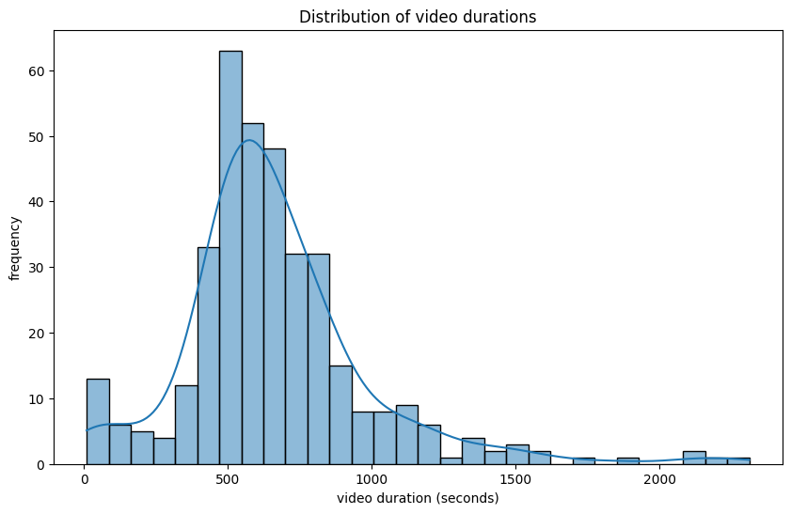
# Revenue distribution
plt.figure(figsize=(10, 6))
sns.histplot(df['Estimated Revenue (USD)'], bins=30, kde=True)
plt.title('Distribution of Estimated Revenue')
plt.xlabel('Estimated Revenue (USD)')
plt.ylabel('Frequency')
plt.show()
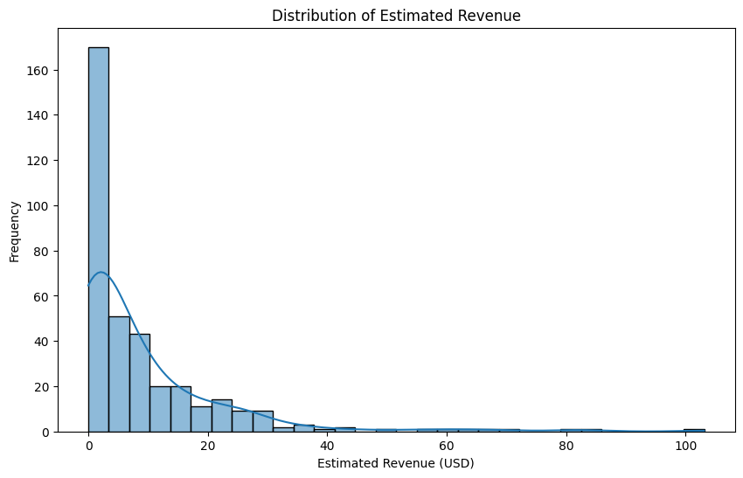
# Select only numeric columns
numeric_df = df.select_dtypes(include=[np.number])
# Compute the correlation matrix
corr = numeric_df.corr()
# Plot the heatmap
plt.figure(figsize=(15, 12))
sns.heatmap(corr, cmap='coolwarm', annot=False, fmt='.2f')
plt.title('Correlation Heatmap')
plt.show()
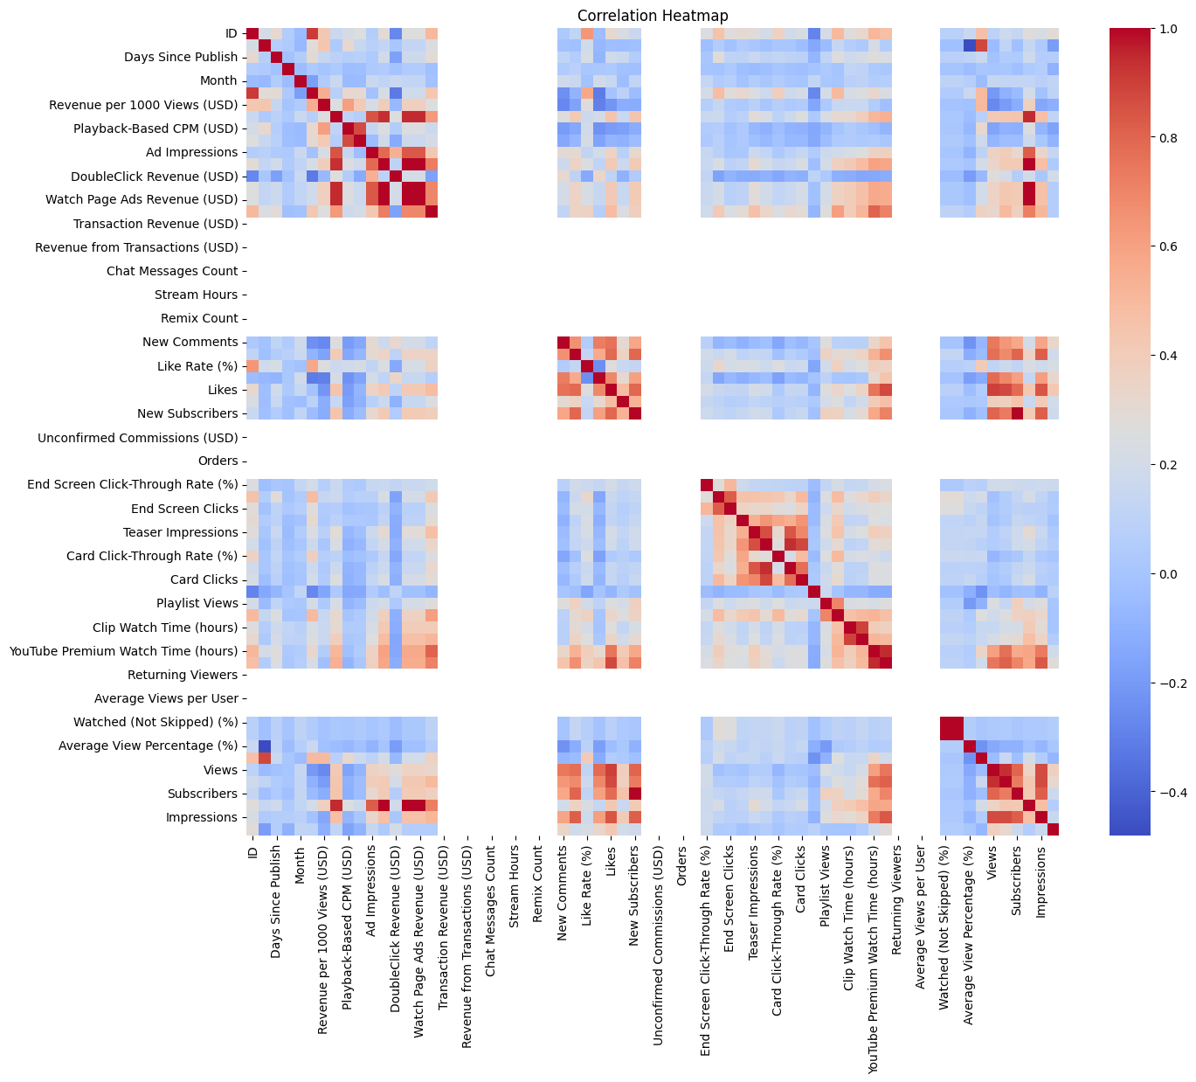
from sklearn.model_selection import train_test_split
from sklearn.ensemble import RandomForestRegressor
from sklearn.metrics import mean_squared_error
# Define features and target variable
X = numeric_df.drop(columns=['Estimated Revenue (USD)'])
y = numeric_df['Estimated Revenue (USD)']
# Split the data into training and testing sets
X_train, X_test, y_train, y_test = train_test_split(X, y, test_size=0.2, random_state=42)
# Initialize and train the model
model = RandomForestRegressor(n_estimators=100, random_state=42)
model.fit(X_train, y_train)
# Make predictions
y_pred = model.predict(X_test)
# Calculate the prediction accuracy
mse = mean_squared_error(y_test, y_pred)
rmse = np.sqrt(mse)
rmse
np.float64(0.45593992214488205)
import seaborn as sns
import matplotlib.pyplot as plt
# Distribution of daily views
sns.histplot(df['Views'], bins=30, kde=True)
plt.title('Distribution of Daily Views')
plt.xlabel('Views per Day')
plt.show()
#Remark: Histograms reveal skewness; heavy right tails often call for log transformations
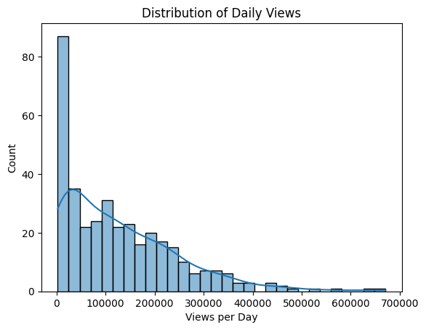
if {'Views', 'Estimated Revenue (USD)'}.issubset(df.columns):
plt.figure(figsize=(12, 6))
sns.scatterplot(data=df, x='Views', y='Estimated Revenue (USD)', palette='coolwarm', alpha=0.7)
plt.title('📈 Revenue vs. Views Colored by Engagement Rate')
plt.xlabel('Views')
plt.ylabel('Estimated Revenue (USD)')
plt.legend(title='Engagement Rate')
plt.tight_layout()
plt.show()
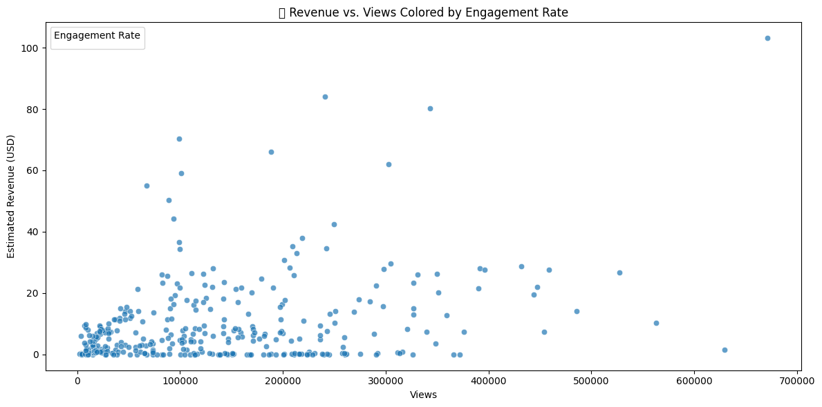
# Aggregate daily total revenue
daily_rev = (
df
.set_index('video_publish_time')
.resample('D')['estimated_adsense_revenue_usd']
.sum()
.reset_index()
)
sns.lineplot(x='video_publish_time', y='estimated_adsense_revenue_usd', data=daily_rev)
plt.title('Daily AdSense Revenue Over Time')
plt.xlabel('Date')
plt.ylabel('Total AdSense Revenue')
plt.show()
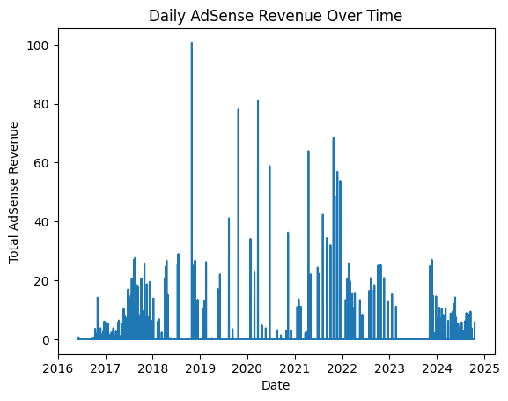
import numpy as np
# Log transform
df['log_views'] = np.log1p(df['Views'])
# Long video flag
median_dur = df['video_duration'].median()
df['is_long'] = (df['video_duration'] > median_dur).astype(int)
# Publish hour and weekend flag
df['publish_hour'] = df['video_publish_time'].dt.hour
df['is_weekend'] = df['video_publish_time'].dt.weekday.isin([5,6]).astype(int)
sns.scatterplot(
x='Views',
y='estimated_adsense_revenue_usd',
data=df
)
plt.title('Views vs AdSense Revenue')
plt.xlabel('Views')
plt.ylabel('AdSense Revenue (USD)')
plt.show()
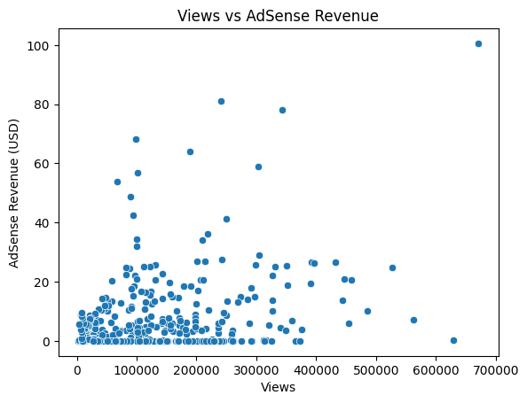

from sklearn.ensemble import RandomForestRegressor
from sklearn.metrics import mean_absolute_error
model = RandomForestRegressor(n_estimators=100, random_state=42)
model.fit(X_train, y_train)
preds = model.predict(X_test)
print('Mean Absolute Error:', mean_absolute_error(y_test, preds))
Mean Absolute Error: 0.2569857534246579

import pandas as pd
import matplotlib.pyplot as plt
import seaborn as sns
from sklearn.ensemble import RandomForestRegressor
from sklearn.model_selection import train_test_split
data = pd.read_csv('youtube_channel_real.csv')
target_column = 'Estimated Revenue (USD)'
# 1. Prepare features and target
features = data.drop(['ID', 'Video Publish Time', target_column], axis=1).columns.tolist()
X = data[features]
y = data[target_column]
# 2. Encode categorical columns
X_encoded = pd.get_dummies(X)
features = X_encoded.columns.tolist() # Update feature list
# 3. Split, train, feature importances
X_train, X_test, y_train, y_test = train_test_split(X_encoded, y, test_size=0.2, random_state=42)
model = RandomForestRegressor(n_estimators=100, random_state=42)
model.fit(X_train, y_train)
importances = model.feature_importances_
feature_importance_df = pd.DataFrame({'Feature': features, 'Importance': importances})
# Sort and select top N features
N = 15 # Show top 15 most important features (change as needed)
feature_importance_df = feature_importance_df.sort_values(by='Importance', ascending=False).head(N)
# Plot
plt.figure(figsize=(10, 6)) # Adjust figure size as needed
sns.barplot(x='Importance', y='Feature', data=feature_importance_df, palette="viridis")
plt.title(f"Top {N} Feature Importances")
plt.xlabel("Importance Score")
plt.ylabel("Feature")
plt.tight_layout()
plt.show()
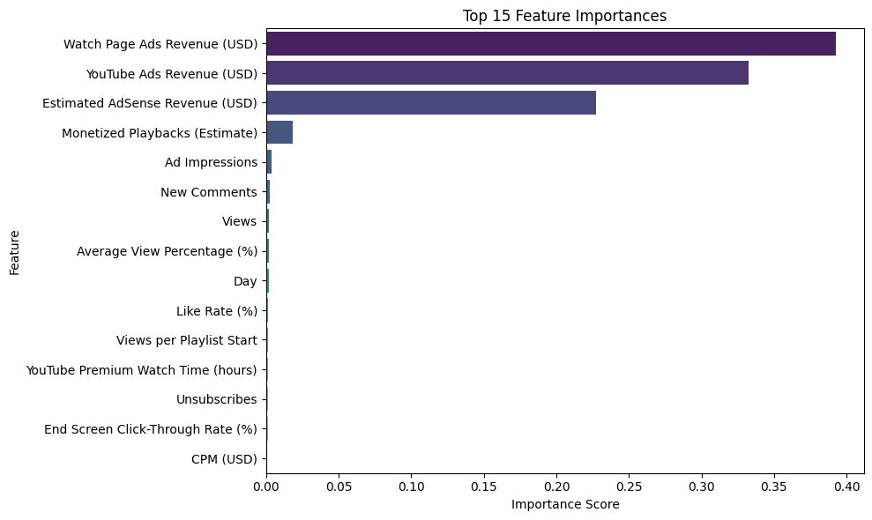
# Clean column names (strip spaces and standardize)
data.columns = data.columns.str.strip()
# Define features and target (edit these if your CSV uses slightly different names)
features = ['Views', 'Subscribers', 'Likes', 'Shares', 'New Comments', 'Average View Percentage (%)']
target = 'Estimated Revenue (USD)'
# Check if all columns exist
missing_features = [col for col in features if col not in data.columns]
missing_target = target not in data.columns
if missing_features or missing_target:
print("Available columns:", list(data.columns))
if missing_features:
print("Missing feature columns:", missing_features)
if missing_target:
print(f"Missing target column: {target}")
raise ValueError("One or more required columns are missing. Please check your CSV file and column names.")
# Select features and target
X = data[features]
y = data[target]
# Split the data
X_train, X_test, y_train, y_test = train_test_split(
X, y, test_size=0.2, random_state=42
)
print("Data split successful.")
Data split successful.
# Import necessary libraries
import numpy as np
import pandas as pd
from sklearn.model_selection import train_test_split
from sklearn.ensemble import RandomForestRegressor
from sklearn.metrics import mean_squared_error, r2_score
X = data.drop(['Views', 'Subscribers', 'Likes', 'Shares', 'New Comments', 'Average View Percentage (%)'], axis=1)
y = data['Estimated Revenue (USD)']
#For demonstration, let's create synthetic data:
from sklearn.datasets import make_regression
X, y = make_regression(n_samples=1000, n_features=10, noise=0.1, random_state=42)
#Split the data
X_train, X_test, y_train, y_test = train_test_split(X, y, test_size=0.2, random_state=42)
#Train the Random Forest Regressor
model = RandomForestRegressor(n_estimators=100, random_state=42)
model.fit(X_train, y_train)
#Predict on test data
y_pred = model.predict(X_test)
#Evaluate the model
mse = mean_squared_error(y_test, y_pred)
r2 = r2_score(y_test, y_pred)
print(f"Mean Squared Error: {mse:.2f}")
print(f"R-squared: {r2:.2f}")
Mean Squared Error: 2621.42
R-squared: 0.84
from sklearn.ensemble import RandomForestRegressor
from sklearn.metrics import mean_absolute_error
model = RandomForestRegressor(n_estimators=100, random_state=42)
model.fit(X_train, y_train)
preds = model.predict(X_test)
print('Mean Absolute Error:', mean_absolute_error(y_test, preds))
Mean Absolute Error: 40.14076474366087

